Secured MCP Registry
Executive Overview, User Journeys and Technical Sequences
When an AI application needs a capability, its Agent Host and MCP Client use an approved configuration to connect to a Secured MCP Server. The server returns the available tool descriptions, the language model selects an appropriate tool, and the MCP Client carries the request and response between the application and the server.
SecureMCP applies safeguards throughout this journey. Policy and consent establish what is allowed; trust checks confirm the service and version; the Reflexive Core watches for changing behaviour; and provenance, audit and alerts keep important activity visible and accountable.
In simple terms: the registry decides what may be trusted, the MCP Client manages the connection, the Secured MCP Server performs the approved work, and SecureMCP continues to monitor the interaction.

How data flows through SecureMCP
The operating model can be understood as five business steps. The detailed MCP protocol sequence is intentionally kept outside this executive view.
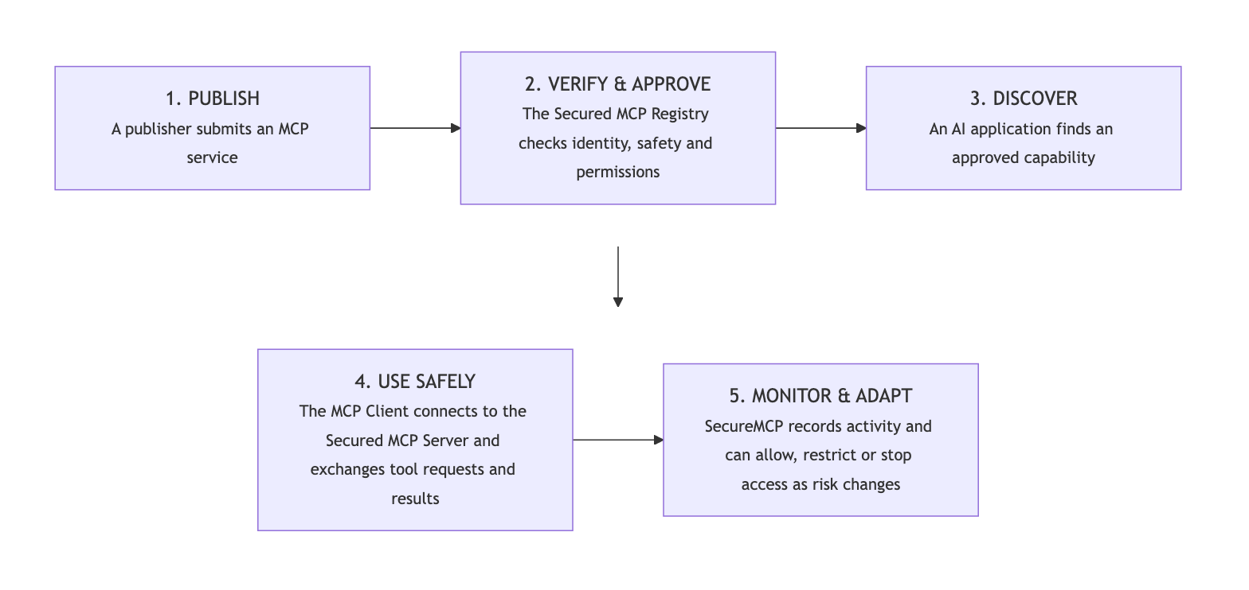
Five-step view: publish, verify, discover, use safely, and monitor

What each part does
1. AI Agent / LLM Application — understands the user’s request, sees the approved tools made available by the Host, and decides when a tool may help.
2. Agent Host — runs the user experience and language model, creates MCP Client connections, applies approvals, and provides tool descriptions and results to the model.
3. MCP Client — maintains one protocol connection to an MCP Server, requests the tool list, sends approved tool calls, and returns tool responses to the Host.
4. Secured MCP Registry — is the governed system of record for publishers, MCP services, approved versions, connection information and lifecycle status.
5. Trust & Verification — confirms the publisher, server version, certification, attestation and current suspension or revocation status.
6. Policy Enforcement — checks whether a user, agent or MCP Client may perform a particular action under the organization’s rules.
7. Reflexive Core — compares current activity with expected behaviour and can allow, restrict, require approval or stop an action as risk changes.
8. Secured MCP Server — publishes tool descriptions and performs approved tool operations through SecureMCP runtime controls.
9. Provenance & Audit — records important identities, decisions and outcomes so activity can be traced and reviewed.
10. Alerts & Notifications — informs the responsible user, publisher or administrator when attention or action is required.
Document scope: This is the business-level operating model. A separate technical appendix can show initialization, tools/list, tools/call, normal/elevated/critical branches, connection shutdown and transport-specific details.

Who takes part?
1. Publisher — The person or organization that creates and maintains an MCP service.
2. Secured MCP Registry — The trusted platform that verifies, approves, publishes and monitors MCP services.
3. AI Agent / LLM Application — The user-facing application that decides when an MCP capability is useful.
4. Agent Host / MCP Client — The software that connects the AI agent to an approved MCP service.

Publisher journey
The publisher journey is designed to turn responsible innovation into a repeatable path: helping teams bring valuable MCP services to market while making trust, transparency and lifecycle accountability part of the experience from the start.
1. Create — The publisher builds an MCP service and explains what it does.
2. Describe — The publisher provides ownership, capability, permission and version information.
3. Submit — The service is sent to the Secured MCP Registry for review.
4. Verify — The registry checks identity, safety information, permissions and the service’s signed proof.
5. Approve and publish — An approved service becomes discoverable to eligible AI agents and applications.
6. Maintain — The publisher releases updates and responds to any new safety findings.

AI Agent / LLM Application journey
For AI agents and LLM-powered applications, the Secured MCP Registry creates a safer path from intent to action. The agent can discover useful capabilities, understand their trust posture, and invoke them through governed access rather than relying on ad hoc integrations.
1. Understand the need — The AI agent identifies a capability required to complete the user’s task.
2. Discover — The MCP client searches the Secured MCP Registry for suitable approved services.
3. Check — The registry confirms the publisher, version, safety status and requested permissions.
4. Authorize — Access is allowed only when organizational policy and user permission requirements are met.
5. Use — The AI agent invokes the approved MCP service and receives the result.
6. Record — The important decisions and actions are recorded for accountability.
7. Respond to change — Access can continue, require approval, be restricted or be stopped when risk changes.

The Components of SecureMCP
SecureMCP brings together connected safeguards that make trusted AI extensibility practical at scale. Each pillar answers a different business question, from “Can we trust this service?” to “Should this action continue right now?”—and together they create the foundation for confident, governed AI growth.

1. Secured MCP Registry
The trusted system of record for MCP publishers, services, versions and security status.
It gives organizations a strategic control point for AI extensibility—one governed place to publish, discover, approve, suspend and retire MCP services as the ecosystem grows.

2. Tool Marketplace and Discovery
The approved catalogue through which AI agents and applications find suitable MCP capabilities.
It makes discovery useful without treating every available service as automatically trusted.

3. Certification and Attestation
The evidence that a publisher and service completed the required checks for a particular version.
Signed proof allows an organization to verify what was assessed and whether that proof is still valid.

4. Policy
The organization’s rules for who may do what, under which conditions and within which limits.
Policy decisions can allow an action, deny it or require additional approval.

5. Contracts
A clear usage agreement between the AI agent and the MCP service.
It defines purpose, permitted scope, obligations and limits before a capability is used.

6. Consent
The record of permission from the appropriate user, owner or organization.
Consent ensures that technically possible actions are not performed without appropriate authority.

7. Provenance
A traceable history of where a request came from, which decisions were made and what happened.
Provenance supports accountability, investigation and confidence in the final outcome.

8. Reflexive Core
The adaptive safety layer that observes behaviour, detects drift and responds to changing risk.
It can allow normal activity, request approval, restrict access or stop a critical action.

9. Introspection
The ability to examine the current request, actor, context and risk before or during execution.
Introspection gives the Reflexive Core the context required to make a meaningful assessment.

10. Alerts
The shared security event and notification capability.
Alerts bring unusual activity, policy failures and urgent risks to the attention of responsible people and systems.

11. Gateway and Audit
The governed entry point for security-aware MCP access and a unified view of security activity.
It simplifies oversight by bringing access and audit information into one controlled layer.

12. Compliance
The reporting layer that turns security evidence into information suitable for governance and assurance.
It helps demonstrate that required controls are operating and provides material for reviews or audits.

13. Federation
A way for trusted SecureMCP environments to share approved trust information.
Federation supports collaboration across teams or organizations without removing local control.

14. Certificate Revocation
The mechanism for declaring that previously trusted proof must no longer be accepted.
Revocation protects users when a credential, publisher or service version becomes unsafe or compromised.

15. Sandboxed Execution
An isolated environment for running higher-risk capabilities with controlled access to systems and data.
Sandboxing limits the impact of unexpected or unsafe behaviour.

Platform foundations around the pillars
The PureCipher Secured MCP Registry adds the practical product services needed to turn these pillars into an operating model for trusted AI ecosystems:
Identity and role-based access: confirms publishers, administrators, reviewers and registered MCP clients.
Publisher and submission services: support packaging, preflight checks, submission and version updates.
Moderation and lifecycle management: support approval, rejection, suspension, deprecation and deregistration.
Client identity and tokens: give each AI agent, service or framework a controlled identity.
OpenAPI ingestion and MCP gateway: allow eligible API operations to be presented through governed MCP toolsets.
Notifications: inform publishers, reviewers, administrators and client owners when action is required.
Durable records: retain registry, account, security, client and audit information.

How the pillars work together
Establish trust: Identity, the Secured MCP Registry, certification and revocation establish whether a service should be considered trustworthy.
Set boundaries: Policy, contracts and consent establish what the AI agent is allowed to do.
Execute safely: The gateway, sandbox and MCP server apply those boundaries during use.
Observe and adapt: Introspection and the Reflexive Core detect changing behaviour and adjust the response.
Maintain accountability: Provenance, audit, alerts and compliance preserve evidence and bring important events to attention.
Share trust carefully: Federation allows trusted environments to collaborate while retaining local governance.

The message to take forward
Trust enables innovation — Publishers should be able to bring new MCP capabilities forward quickly, with clear evidence that they are safe, accountable and ready to use.
Discovery should be governed by confidence — AI agents should find approved capabilities through trusted pathways, not fragmented or opaque integrations.
Trust must be continuous — Assurance should follow every MCP service across its lifecycle, from publication to update, suspension or retirement.
Governance should adapt in real time — The Reflexive Core should help the system respond as behaviour, context and risk evolve.
Scale should remain accountable — As adoption grows, every important decision should remain traceable, reviewable and useful for strengthening trust.

Progressive technical walkthrough
The diagrams below move from user intent to implementation detail. Each level adds participants and decisions while preserving the same operating model.
1. Level 1: Executive flow — the five-step diagram near the beginning explains publish, verify, discover, use safely, and monitor.
2. Level 2: User journeys — separate publisher and AI-agent sequences show who initiates each action and what outcome is returned.
3. Level 3: MCP protocol — the client/server sequence shows initialization, tool discovery, tool calls, responses, and shutdown.
4. Level 4: SecureMCP runtime controls — the final sequence adds trust, policy, Reflexive Core, provenance, audit, and alert decisions.
Reading convention: solid arrows are requests or actions; dashed arrows are returned decisions or results; alternate frames show different outcomes.

Level 2A — Publisher sequence
This view follows an MCP service from submission through review, publication, updates, suspension, or retirement.
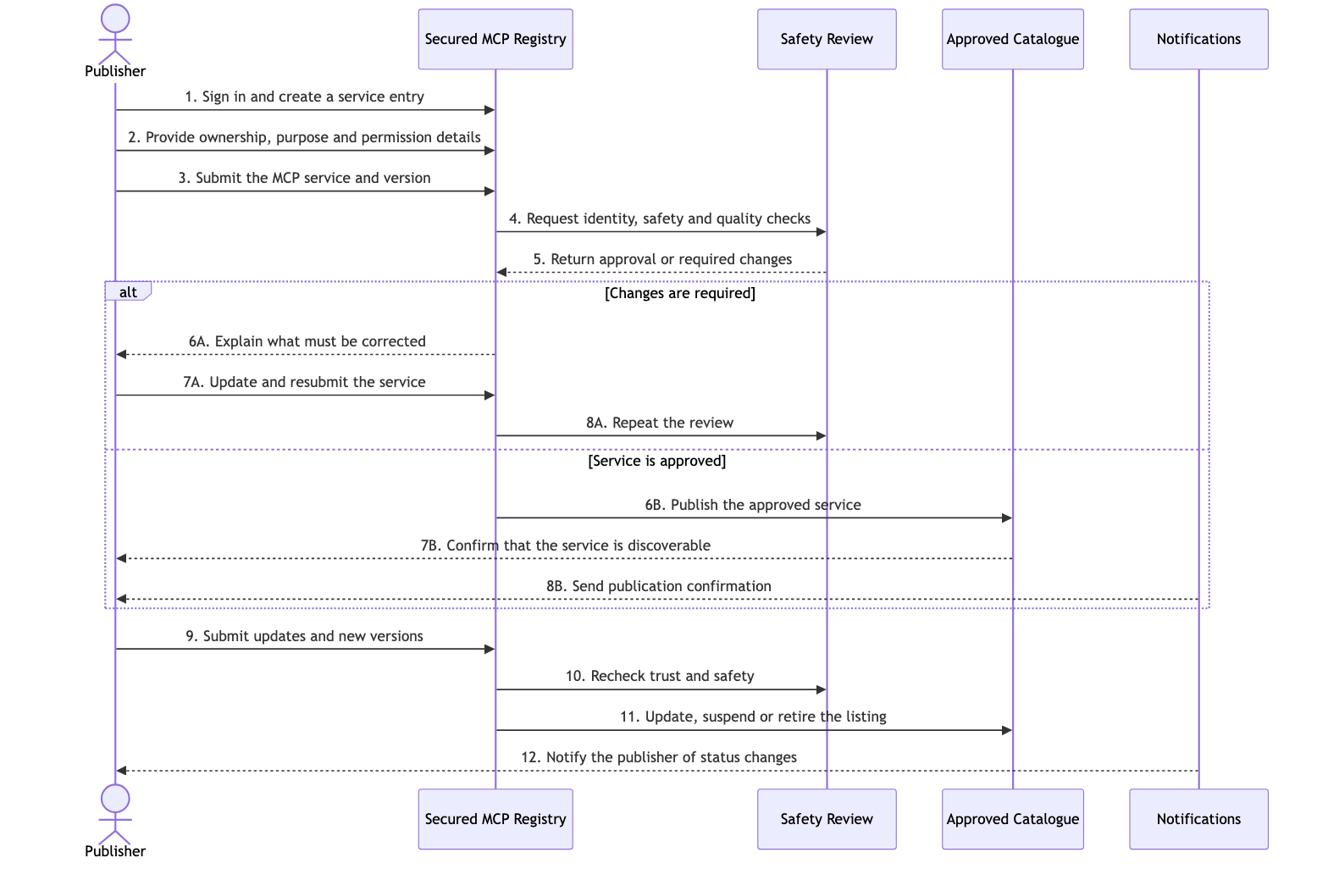
Publisher submission, approval and lifecycle sequence

Level 2B — AI Agent / LLM Application sequence
This view follows a user request from capability discovery through governed execution. It introduces normal, elevated-risk, and critical-risk outcomes without exposing every internal service.
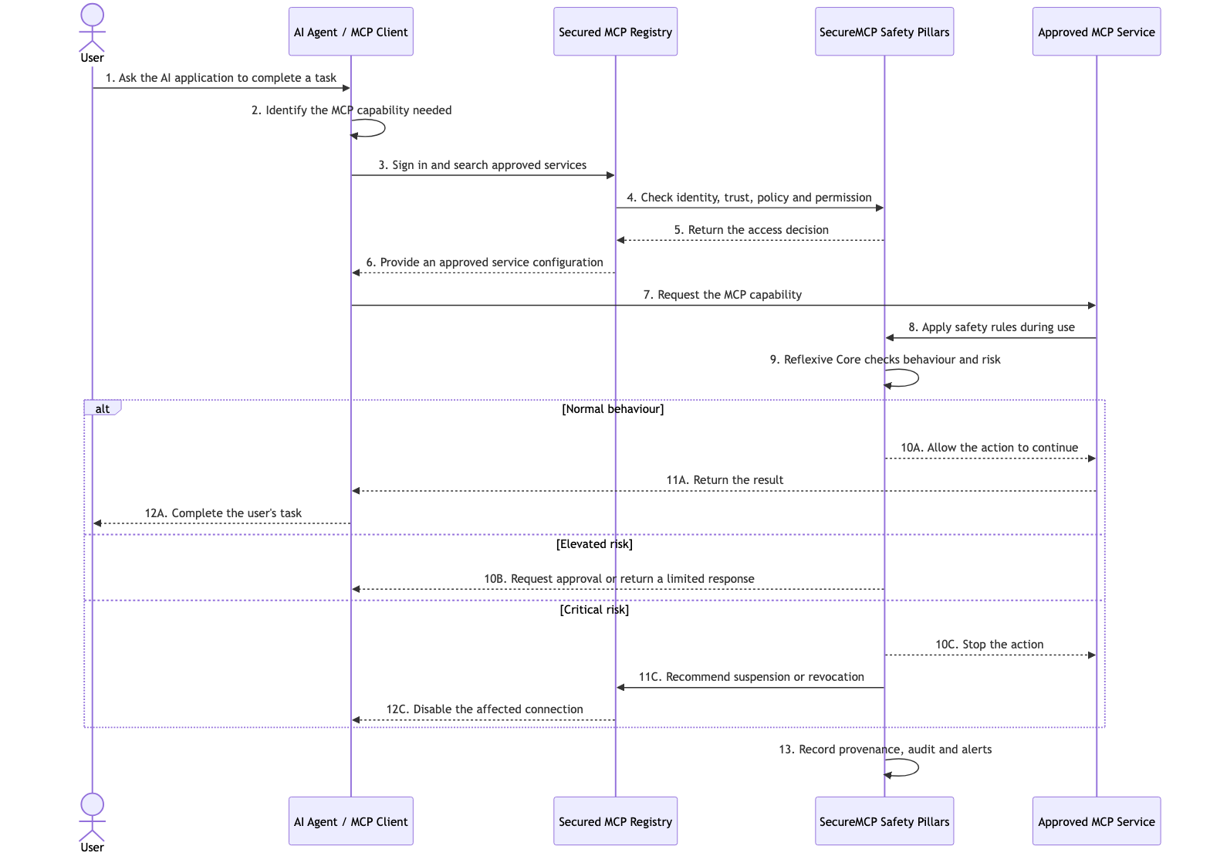
AI-agent discovery, authorization, execution and risk-response sequence

Level 3 — Standard MCP client/server sequence
This view separates the Agent Host, MCP Client, language model, and MCP Server. It also shows where the client and server start and stop.
1. Client lifecycle — the Agent Host starts and closes the MCP Client.
2. Server lifecycle — a local server may be started and stopped with the client; a remote server normally remains running while the transport connection closes.
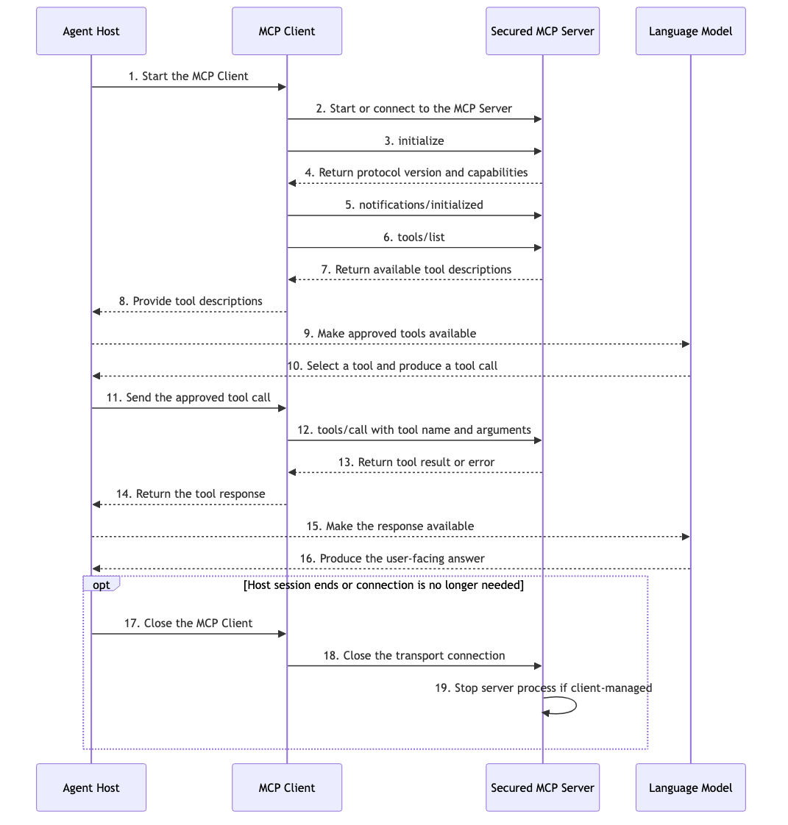
MCP initialization, tools/list, tools/call, response and shutdown sequence

Level 4 — SecureMCP runtime control sequence
This most technical view expands the governed runtime. The Registry verifies the approved service and configuration; Policy Enforcement decides whether the requested action is allowed; the Reflexive Core evaluates current behaviour and changing risk; Provenance and Audit record the decision; and Alerts and Notifications surface events requiring attention.
1. Normal behaviour — execution continues and the result is returned.
2. Elevated risk — execution may require approval, be restricted, or return a limited response.
3. Critical risk — execution is blocked, security status may be updated, and responsible owners are notified.
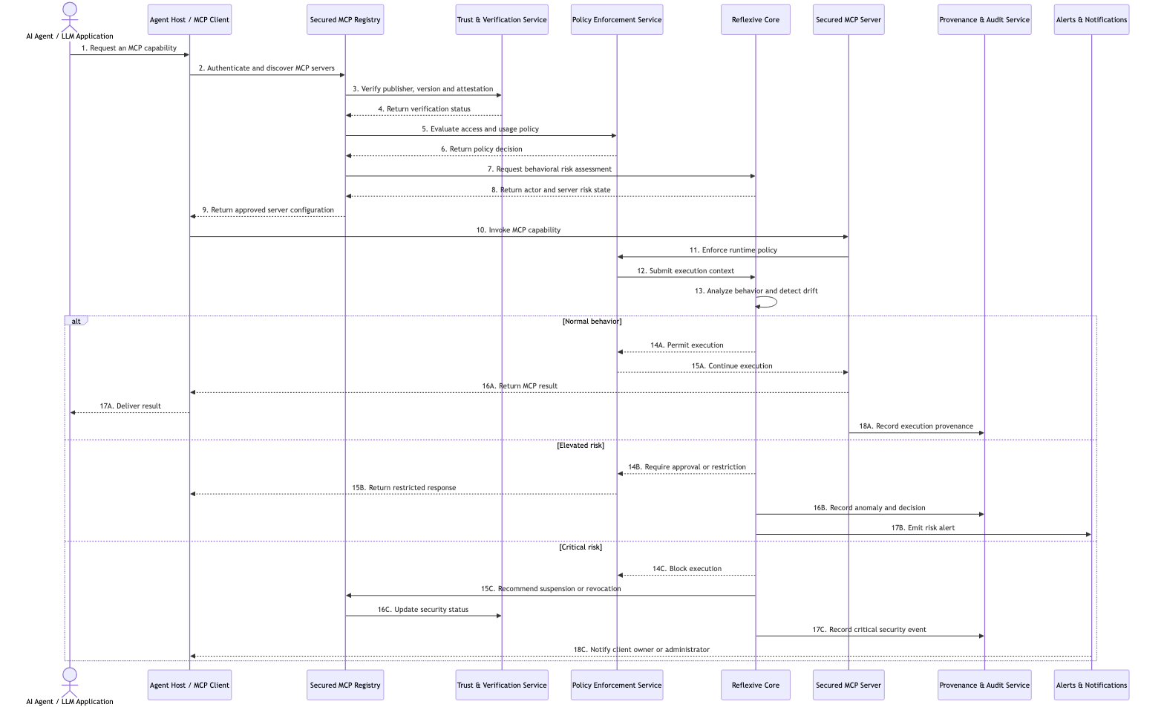
SecureMCP verification, policy, Reflexive Core, audit and alert sequence

Registry comparison and business use cases
This section compares how common MCP ecosystems support discovery and connection, then applies the Secured MCP Registry to practical organizational scenarios.

Executive conclusion
1. Claude Code — connects to MCP servers that a user or team configures. Its documentation provides examples and points users toward community servers, but it does not describe Claude Code as automatically selecting servers from one mandatory registry.
2. Codex — also connects to explicitly configured MCP servers. Local Codex clients share MCP configuration, while hosted ChatGPT and Codex experiences can receive MCP-backed tools through plugins.
3. Public registries — primarily help people discover, publish, install or host MCP servers. Their focus ranges from open metadata to managed credentials, containers, gateways and operational monitoring.
4. Secured MCP Registry — is positioned as a governed control plane rather than only a directory. It combines publication and discovery with certification, policy, contracts, consent, provenance, adaptive risk controls and lifecycle actions.

Important terminology
Claude Code and Codex are MCP clients, not registries. A registry helps users discover or govern MCP servers; the client connects to the selected server after configuration or installation.
Therefore, the most accurate question is not “Which registry does Claude Code or Codex use?” but “How do these clients discover, configure and govern MCP servers?”

How Claude Code works with MCP
1. Connection model — Users add local or remote MCP servers through Claude Code commands or configuration.
2. Team sharing — Project-scoped server definitions can be stored in a shared .mcp.json file.
3. User approval — Claude Code asks for approval before using project-scoped MCP servers from shared configuration.
4. Authentication — Remote HTTP and SSE servers can use OAuth, headers or other configured credentials.
5. Discovery — Anthropic documentation lists popular servers and directs users to broader community sources, while installation remains an explicit user or team action.
6. Security message — Anthropic warns that third-party servers are not all verified and should be installed only when trusted.

How Codex works with MCP
1. Connection model — Codex supports local STDIO servers and remote Streamable HTTP servers.
2. Shared configuration — The ChatGPT desktop app, Codex CLI and Codex IDE extension share MCP configuration on the same Codex host.
3. Project control — Servers can be configured globally or in a trusted project through config.toml.
4. Tool control — Codex supports server enablement, required-server settings, tool allowlists, tool denylists and approval modes.
5. Hosted tools — ChatGPT and Codex can also receive remote MCP-backed tools through installed plugins rather than local MCP configuration.
6. Discovery — Official Codex documentation provides examples of useful MCP servers, but does not describe a built-in public-registry search command comparable to GitHub Copilot CLI’s registry search.

Registry and catalogue comparison

1. Official MCP Registry
Primary role: A community-driven central repository and API for publishing and discovering MCP server metadata.
Strength: Open ecosystem metadata, standard registry interfaces and interoperability.
Boundary: It is currently described as preview. Published version metadata is immutable, and its FAQ directs malicious-server reports to the underlying package registry and a GitHub issue.
SecureMCP relevance: Best used as an ecosystem source of record or upstream feed, not by itself as a complete enterprise runtime-security system.

2. GitHub MCP Registry
Primary role: A discovery experience for finding official or relevant MCP servers within GitHub-oriented developer workflows.
Strength: Fast discovery and installation, plus enterprise support for internal registries and allowlist controls in supported GitHub environments.
Boundary: Its strongest value is developer workflow integration and organizational distribution policy.
SecureMCP relevance: A useful comparison for self-service discovery, but SecureMCP goes further into execution-time governance and adaptive risk.

3. Docker MCP Catalog and Toolkit
Primary role: A curated catalogue designed to make MCP servers easy to discover, deploy and run with Docker tooling.
Strength: Container packaging, repeatable deployment and desktop-based operational convenience.
Boundary: It is especially strong when the main problem is safely packaging and running third-party server software.
SecureMCP relevance: SecureMCP can complement this model by governing which containerized server may be used, by whom and under which policy.

4. Smithery
Primary role: An open registry combined with managed MCP connections, OAuth, token refresh and credential storage.
Strength: Low-friction connection management for agent builders and multi-user applications.
Boundary: It reduces integration effort by managing authentication and connection lifecycle.
SecureMCP relevance: SecureMCP differentiates through organization-owned policy, certification, consent, contracts, provenance and reflexive controls.

5. Glama
Primary role: A large MCP directory with hosting, deployment, gateway, logs, analytics and per-tool access controls.
Strength: Discovery plus production operations, health checks, hosting and connection-profile security.
Boundary: It combines a public directory with operational infrastructure and runtime visibility.
SecureMCP relevance: It is the closest operational comparison, while SecureMCP emphasizes an integrated governance model across the full trust lifecycle.

6. PureCipher Secured MCP Registry
Primary role: A governed registry and security control plane built around SecureMCP.
Strength: Publisher verification, certification, policy, contracts, consent, provenance, Reflexive Core, alerts, moderation and lifecycle control.
Boundary: It is intended to make trust decisions before publication, during discovery and while an MCP capability is running.
SecureMCP relevance: Its clearest position is “governed MCP adoption for organizations,” rather than “the largest public directory.”

Comparison at a glance
Option | Best suited to | Discovery model | Governance emphasis
Official MCP Registry | Open ecosystem metadata | Public API and registry | Publisher metadata and ecosystem reporting
GitHub MCP Registry | Developer self-service | GitHub-integrated search | Enterprise allowlists in supported GitHub environments
Docker MCP Catalog | Packaged deployment | Curated Docker catalogue | Container execution and operational consistency
Smithery | Managed connections | Open registry and connection API | OAuth, credentials and session lifecycle
Glama | Hosted MCP operations | Directory plus deployment | Gateway, logs, health and per-tool controls
Secured MCP Registry | Governed organizational adoption | Approved internal/public catalogue | Policy, consent, contracts, provenance and adaptive risk

Where the Secured MCP Registry is different
1. Governance before discovery — Only approved publishers, services and versions should become visible to the intended audience.
2. Policy during execution — A service can be discoverable but still restricted for a particular user, agent, purpose or environment.
3. Consent and contracts — Access can depend on explicit permission and an agreed purpose rather than on installation alone.
4. Traceable provenance — Important requests, decisions and outcomes can be recorded for investigation and accountability.
5. Adaptive protection — The Reflexive Core can detect behavioural drift and escalate from normal operation to approval, restriction or blocking.
6. Lifecycle enforcement — Moderators can approve, suspend, deprecate, revoke or deregister services and versions.
7. Client identity — AI agents, services and frameworks can receive controlled identities and tokens instead of appearing as anonymous consumers.
8. Enterprise deployment choice — The registry can be operated as an internal catalogue, a curated public service or a federated trust environment.

Business use cases

1. Enterprise-approved AI tools
Situation: Employees want Claude Code, Codex or another AI client to use Jira, GitHub, databases and internal APIs.
Registry response: The organization publishes an approved catalogue and blocks or discourages unreviewed MCP servers.
Key pillars: Registry, identity, certification, policy and client tokens.

2. Regulated financial-services agent
Situation: An AI agent prepares a customer or transaction analysis using sensitive systems.
Registry response: Consent, purpose limits and audit evidence ensure that the agent accesses only approved data for the approved task.
Key pillars: Policy, contracts, consent, provenance, compliance and alerts.

3. Healthcare workflow assistant
Situation: A clinical or administrative assistant needs controlled access to patient-related services.
Registry response: The registry approves specific service versions, while runtime controls limit access by role, purpose and environment.
Key pillars: Certification, policy, consent, sandboxing, provenance and revocation.

4. Third-party MCP vendor onboarding
Situation: A SaaS vendor wants its MCP service to be available to enterprise AI agents.
Registry response: The publisher submits identity, capability, permission and version evidence; reviewers approve or request remediation.
Key pillars: Publisher service, certification, moderation, registry and notifications.

5. Developer self-service with guardrails
Situation: Engineering teams want easy access to documentation, observability, browser and repository tools.
Registry response: Developers discover pre-approved servers without waiting for a manual installation review each time.
Key pillars: Catalogue, install guidance, policy profiles and client identity.

6. Secure API-to-MCP conversion
Situation: An organization wants to expose selected internal REST operations to AI agents.
Registry response: OpenAPI operations are converted into governed MCP toolsets while credentials remain controlled.
Key pillars: OpenAPI ingestion, gateway, policy, contracts, provenance and alerts.

7. High-risk production action
Situation: An AI agent requests a deployment, payment, account change or destructive infrastructure action.
Registry response: The request is checked against policy and consent, executed in a restricted environment where appropriate and stopped when behaviour becomes abnormal.
Key pillars: Policy, consent, contracts, sandbox, Reflexive Core and audit.

8. Rapid incident response
Situation: A trusted server version or publisher credential becomes compromised.
Registry response: Administrators revoke trust, suspend the listing, notify affected clients and prevent new connections.
Key pillars: Revocation, registry lifecycle, alerts, client inventory and provenance.

9. Multi-agent workflow control
Situation: A coordinator agent delegates work to specialist agents that use different MCP services.
Registry response: Each agent receives a distinct identity and only the tools required for its assigned role.
Key pillars: Client identity, policy, contracts, consent and provenance.

10. Federated organization
Situation: Business units or partner organizations want to share approved MCP services without surrendering local governance.
Registry response: Trust information can be exchanged while each organization keeps its own approval and policy decisions.
Key pillars: Federation, registry, certification, revocation and local policy.

11. Controlled version promotion
Situation: A publisher needs to move an MCP service from development to testing and production.
Registry response: Each version is reviewed, certified and promoted according to environment-specific policy.
Key pillars: Policy versioning, certification, moderation, provenance and notifications.

12. Shadow MCP visibility
Situation: Teams are using untracked MCP servers with unknown permissions or credentials.
Registry response: The organization establishes a registered client inventory and an approved catalogue, making exceptions visible and reviewable.
Key pillars: Client registry, catalogue, policy, audit and alerts.

Recommended positioning
1. Do not compete on catalogue size alone — Public registries and directories are already optimized for broad discovery.
2. Use public registries as upstream sources — Import or reference ecosystem metadata, then apply organizational approval and security enrichment.
3. Lead with governed adoption — Position the Secured MCP Registry as the place where an organization decides which MCP services and versions may be trusted.
4. Emphasize runtime protection — The strongest distinction is the combination of policy, consent, contracts, provenance and the Reflexive Core after installation.
5. Support multiple clients — The registry should serve Claude Code, Codex and any standards-compliant MCP client rather than becoming tied to one model vendor.

Sources
1. Anthropic: Connect Claude Code to tools via MCP — https://docs.anthropic.com/en/docs/claude-code/mcp
2. OpenAI Codex Manual: Model Context Protocol — https://learn.chatgpt.com/docs/extend/mcp
3. Official MCP Registry API — https://registry.modelcontextprotocol.io/docs
4. Official MCP Registry FAQ — https://modelcontextprotocol.io/registry/faq
5. GitHub: Meet the GitHub MCP Registry — https://github.blog/ai-and-ml/github-copilot/meet-the-github-mcp-registry-the-fastest-way-to-discover-mcp-servers/
6. GitHub: Internal MCP registry and allowlist controls — https://github.blog/changelog/2025-09-12-internal-mcp-registry-and-allowlist-controls-for-vs-code-insiders/
7. Docker MCP Registry — https://github.com/docker/mcp-registry
8. Smithery documentation — https://smithery.ai/docs
9. Smithery Connect — https://smithery.ai/docs/use/connect
10. Glama MCP hosting and gateway — https://glama.ai/mcp/hosting
Research note: Public product capabilities change quickly. This comparison reflects official documentation reviewed on 28 July 2026. Statements about the PureCipher Secured MCP Registry are based on the current project implementation and architecture.

